**Computer Graphics LAB**

**(**Experiment 9**)**

|  |
| --- |
| **NAME :** Ashish Sharma  **SAP ID :** 500087115  **BATCH :** B-4 |

* Point Clipping Algorithm Implementation using C Programming Language.

**CODE -**

#include<stdio.h>

#include<conio.h>

#include<graphics.h>

int main()

{

int gm,gr,xc_min, yc_min, xc_max, yc_max,x,y,c;

detectgraph(&gm, &gr);

initgraph(&gm, &gr, "c:\\tc\\BGI");

printf("Enter the clip-min coordinate --> \n");

scanf("%d%d", &xc_min, &yc_min);

printf("Enter the clip-max coordinate --> \n");

scanf("%d%d", &xc_max, &yc_max);

rectangle(xc_min,yc_max,xc_max,yc_min);

printf("Enter the coordinate of the POINT--> \n");

scanf("%d%d", &x, &y);

detectgraph(&gm, &gr);

initgraph(&gm, &gr, "d:\\tc\\BGI");

rectangle (xc_min,yc_max,xc_max,yc_min);

printf("*******POINT CLIPPING******\n");

if ((xc_min<x) && (x<xc_max))

{

if ((yc_min<y) && (y<yc_max))

{

printf("The point is inside the clip window\n");

}

}

else

printf("The point is outside the clip window \nThe point is clipped\n");

}

**OUTPUT 1 -**

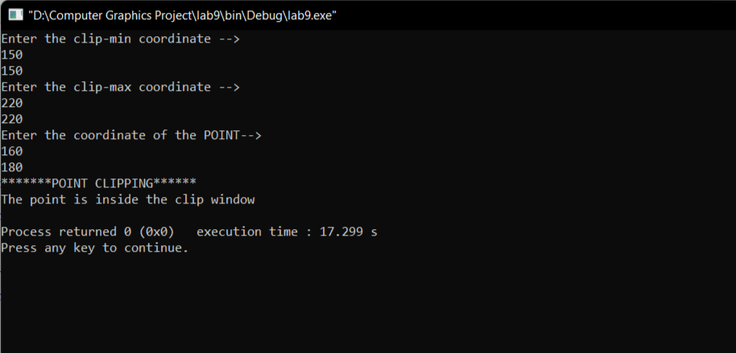

**OUTPUT 2 -**

